Module 9 - Portfolio Exercise: Make it interactive!
Farrell Sevillen Arya
S4270969
27/10/26

Master visualization
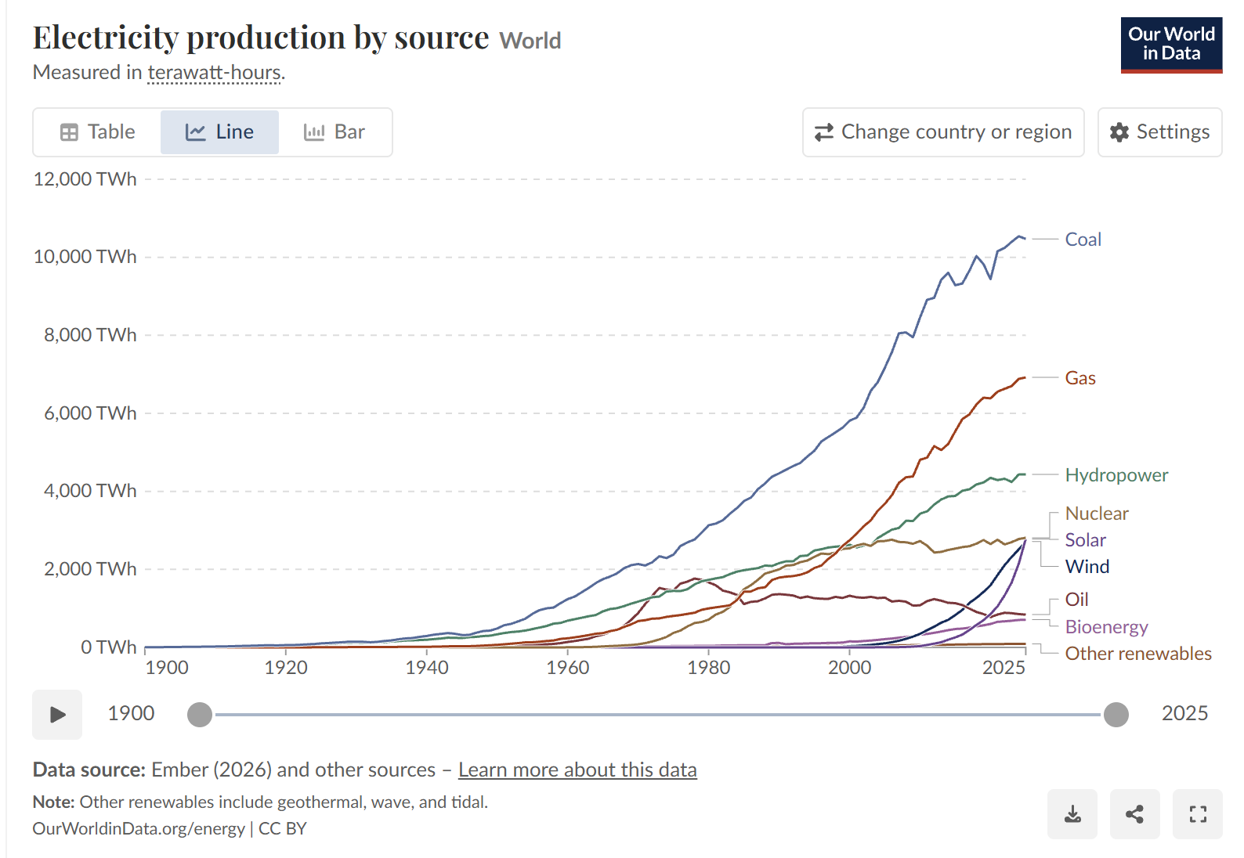
Figure 1. Master Data Visualization: Electricity production by source. Sourced from Our World in Data (2026).

Interactive Recreation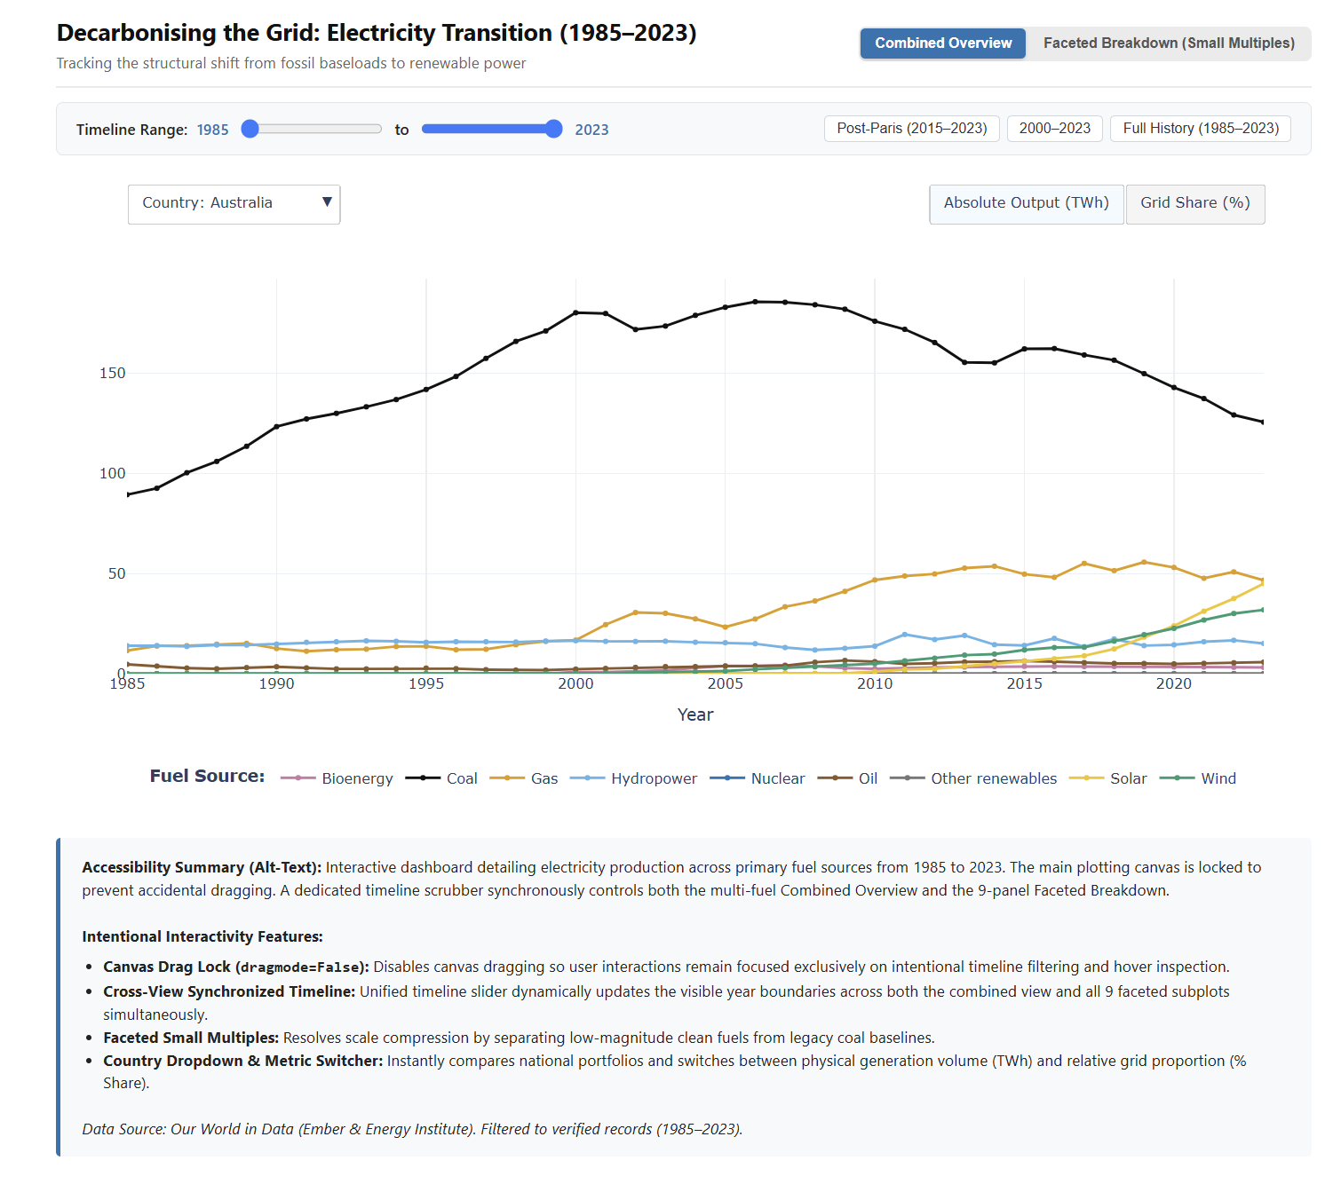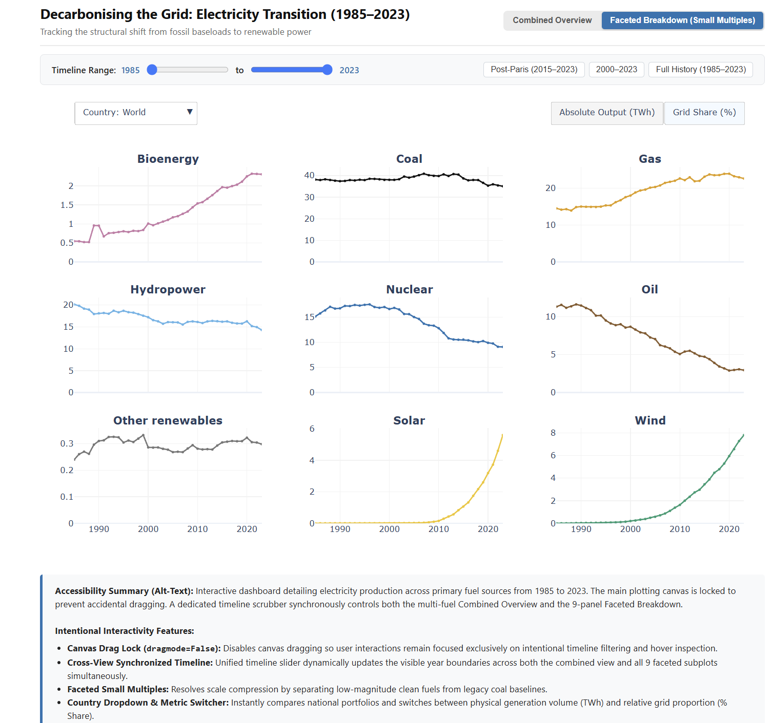
Figure 2. Replicated and enhanced interactive visualization featuring a Combined Overview and Faceted Small Multiples with dynamic metric toggling, timeline filtering, and country selection using data from Our World in Data (2026).

How I created the interactive visualization
How I created the interactive visualization was first using the electricity production by source dataset from Our World in Data (2026). The raw data had entries going back to 1900 and included hundreds of countries, but a lot of the older years had no data for modern renewables like solar and wind. I filtered the dataset so that it only takes the data from 1985 until 2023. I also stopped at 2023 because recent years like 2024 and 2025 had incomplete reporting in some countries like Indonesia, which made the lines drop off suddenly. I chose six key countries/entities to focus on: Australia, Germany, Indonesia, United States, China, and the World.
After cleaning the data, I started building the visualization in Python using Plotly. A major problem with putting all nine fuel types on one chart is that high-volume sources like coal completely squash smaller sources like solar, wind, and bioenergy down to the bottom, making them look flat. To solve this and avoid junk interactivity, I created two main views that you can switch between with a button at the top:
- 1. Combined Overview: This shows all the fuel sources together on one graph with an interactive legend, so you can see the overall energy mix and how fossil fuels are being replaced.
- 2. Faceted Breakdown (Small Multiples): This splits the 9 energy sources into their own separate subplots on a 3x3 grid. This lets you see the trend and growth shape of each energy source individually without high coal numbers compressing them.
I also added interactive buttons so you can toggle between Absolute Output (TWh) and Grid Share (%), which changes the y-axis to show percentages from 0% to 100%. This is useful because TWh can hide structural changes if total energy demand is growing. For the time filter, I added a dual-handle range slider and preset buttons (like Post-Paris 2015 to 2023, and last 20 years) so you can easily scrub through time. I also locked the main chart canvas from accidental click-and-drag panning so that it doesn't move around when you only want to inspect data or use the slider.
A problem I faced was that when putting titles, country dropdowns, and buttons directly on the Plotly canvas, they kept clipping and overlapping each other when the browser tab got smaller. The range slider was also overlapping the year labels and legend at the bottom. To fix this, I moved the controls into clean HTML containers above the chart and adjusted the margins. Another issue was that for countries with zero production in certain fuels (like Nuclear in Australia), the y-axis glitched into negative numbers (-1 to 1), so I anchored all the y-axes to start at zero.

How I developed the color palette & accessibility
For the color palette, I used the Okabe-Ito colorblind-safe palette (Siegal Lab, n.d.) so that the visualization is accessible to people with color vision deficiencies like deuteranopia, protanopia, and tritanopia. I assigned distinct colors for all the sources: Charcoal for Coal, Orange for Gas, Umber brown for Oil, Dark Blue for Nuclear, Sky Blue for Hydropower, Green for Wind, Deep Yellow for Solar, Purple for Bioenergy, and Grey for Other renewables. I also added discrete dots on each year and unified hover tooltips so users can easily read the exact numbers without guessing off the axis ticks, and wrapped the chart in accessible HTML with alt-text.

Data Card

Parameter | Attribute Details
Title | Electricity Production by Source (1985–2023)
Summary | An interactive time-series visualization tracking electricity generation profiles and grid decarbonisation from 1985 to 2023 across six economies: Australia, Germany, Indonesia, United States, China, and the World across nine fuel sources (Coal, Gas, Oil, Nuclear, Hydropower, Wind, Solar, Bioenergy, and Other renewables).
Data Sources | Primary Source / Host: Our World in Data. (2026). Electricity Production by Source [Data set]. https://ourworldindata.org/grapher/electricity-production-by-source  Original Source 1: Ember. (2026). Yearly Electricity Data [Data set]. https://ember-climate.org/data/data-tools/data-explorer/  Original Source 2: Energy Institute. (2026). Statistical Review of World Energy [Data set]. https://www.energyinst.org/statistical-review
Mapping | X axis: Year, continuous annual time steps from 1985 to 2023 (OWID / Ember / Energy Institute, 2024).  Y axis: Electricity Output / Share — measured in Terawatt-hours (TWh) for absolute output, or percentage of total gross generation (0% to 100%) for grid share mode (OWID / Ember / Energy Institute, 2026).
Important Notes | Preprocessing and Filtering: The raw dataset contains global historical electricity figures across hundreds of countries dating back to 1900. The data was filtered to the 1985–2023 period to ensure complete, disaggregated reporting for modern renewables and eliminate unrecorded historical baselines. Data was filtered to six key representative entities. Total TWh and percentage grid shares were calculated for each source per year.  Missing Data: Null values were filled with 0. Preliminary data for 2024–2025 was excluded due to reporting lag in developing economies like Indonesia.
Access | Direct page access to download data: https://ourworldindata.org/grapher/electricity-production-by-source?overlay=download-data

References
Ember. (2026). Yearly electricity data [Data set]. https://ember-climate.org/data/data-tools/data-explorer/

Energy Institute. (2026). Statistical review of world energy [Data set]. https://www.energyinst.org/statistical-review

Our World in Data. (2026). Electricity production by source [Data visualization and data set]. Global Change Data Lab. https://ourworldindata.org/grapher/electricity-production-by-source

Siegal Lab. (n.d.). Color palette. Department of Biology and Center for Genomics & Systems Biology, New York University. https://siegal.bio.nyu.edu/color-palette/

